Dialogflow Chat and Integration with your Angular Based UI [COVID19-DASHBOARD]

**Note:** You should be aware of Basic Dialogflow, Django Rest-API, Angular to understand this Project

Technology Used:

|  |  |
| --- | --- |
| **Dialogflow** | For developing NLP Based chatbot |
| **Django** | For Developing python based backend api for webhook |
| **Angular** | For Developing Chatbot window and Dashboard |
| **Google Geochart** | Plotting worldmap with countrywise coid19 cases |

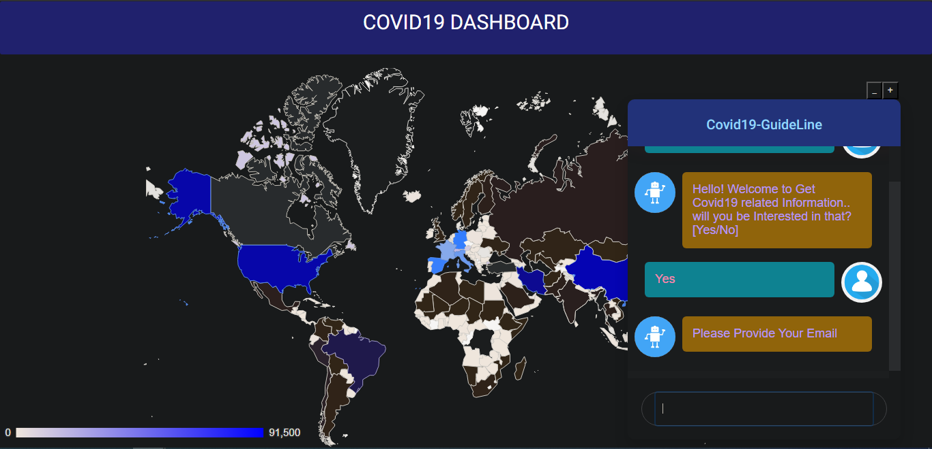

Dialogflow Flow-Chart

NO

YES

**Welcome user if he/she is interested in covid19 guideline**

No

NO

Provide Details and Close Conversation

YES

Ask User if any other Queries

Close Conversation

Send Mail to the User

Close Conversation

If User is not interested send Thank you mail for visiting us

User Information [Email, Phone Number, Pin code]

Dialogflow

**Step 1: Welcome Intent:** Once user says Hi or Hello then our welcome Intent will respond if User is interested to know more about Covid19 Guideline.

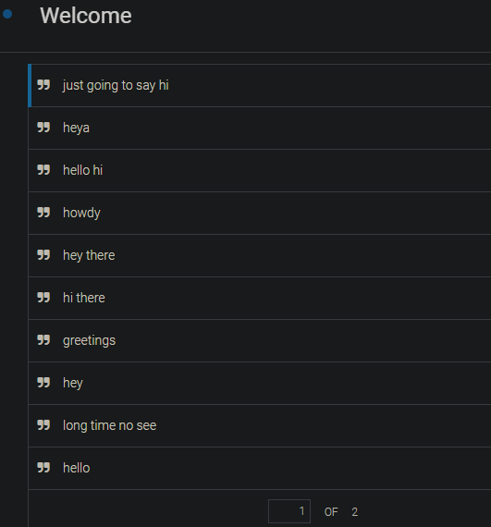

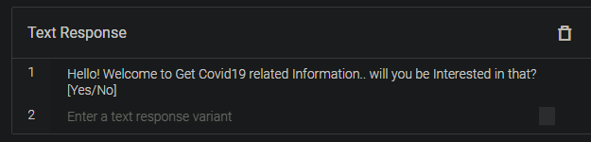

**Step2: InformationGathering Intent:** Add training phases like Yes, Yeah, sure as a response of Welcome Intent.

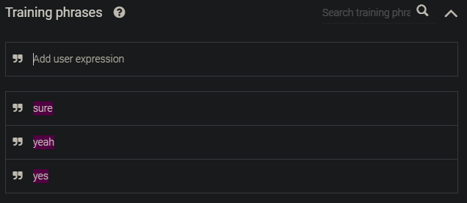

Once User says Yes, you can ask for ( Email , Phone Number and Zip Code). You may mark all of them as required field if you want to store those and sent mail or sms to the respective emailed or phone number.

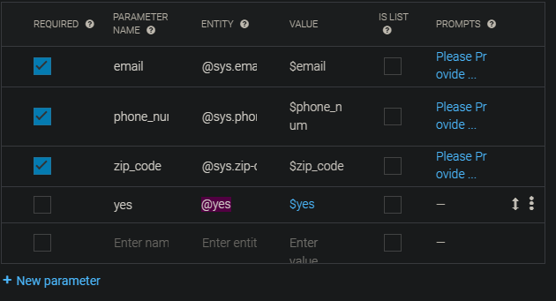

Here we are going to send Covid19 Report details to particular Email id of User. So we are going to get all parameters details. We will activate Webhook enable link below and need to provide our API link in Fulfillment tab.

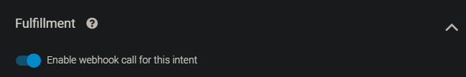

Click on Fulfillment tab to provide your web API.

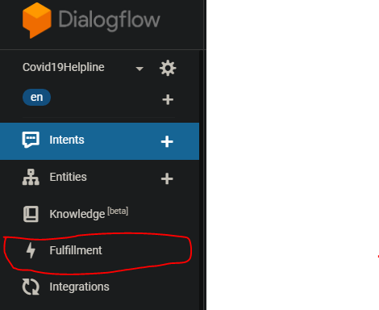

Once you click Fulfillment tab, Below window will appear. You need to enable the webhook button and provide the API you have developed. Now interesting fact is that this URL has to be in public Domain not your localhost. So to forward your localhost to public Domain we will use **ngrok** [This helps us to provide Public URLs for exposing your local web server.]

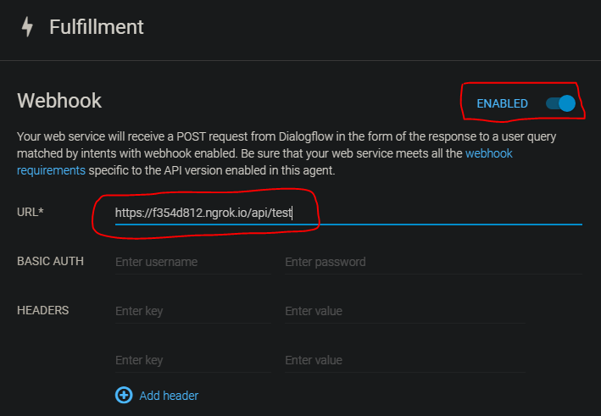

**Steps to Execute ngrok:**

1. Download ngrok: <https://ngrok.com/>
2. Run your Django localhost like below.



1. Open Command Prompt, go to ngrok folder where you find ngrok.exe (For Windows). Run below command.



1. Once you run the above command you will see below CMD where you will get the forwarded public URL.

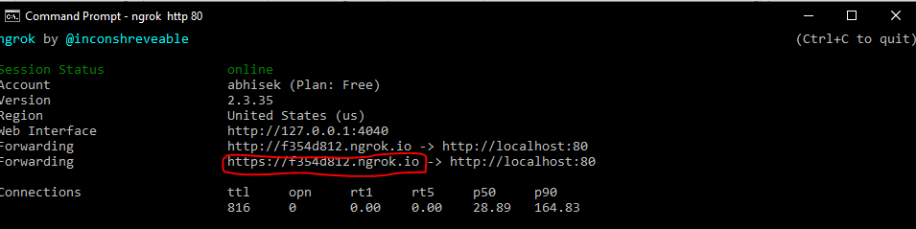

Above is the public URL which has to be used for your REST- API webservice. We will discuss in Django Rest-Api part for request response part via webhook and how we are sending details to particular Emailid. Below is the Reponse you can send using your API or from Text Response. Here we are sending email via webhook but response from default dialogflow response.

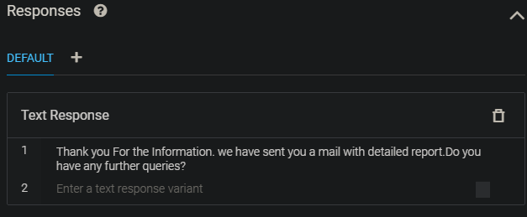

Now you can ask some other queries. There is a covid19 FAQ also available in knowledgebase.

**How to Use Knowledge Base for FAQ:**

**Step1:** Click on Knowledge Menu**.**

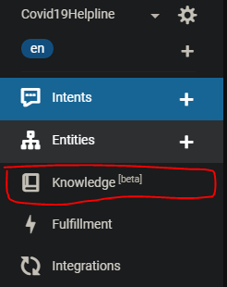

**Step2:** click on “create knowledge base”

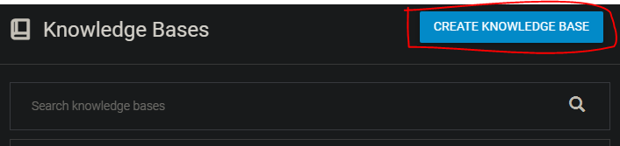

**Step3:** Provide knowledgebase Name and save it.

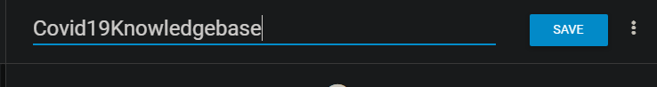

**Step4:** Click on Create the first one.

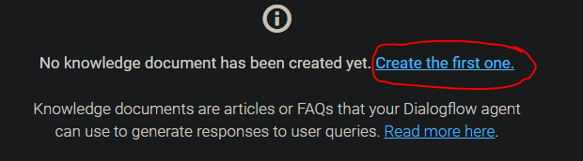

Step 5: Fill all below marked fields and click on create. We have used United Nations FAQ url for Covid19 guideline <https://www.un.org/en/coronavirus/covid-19-faqs>

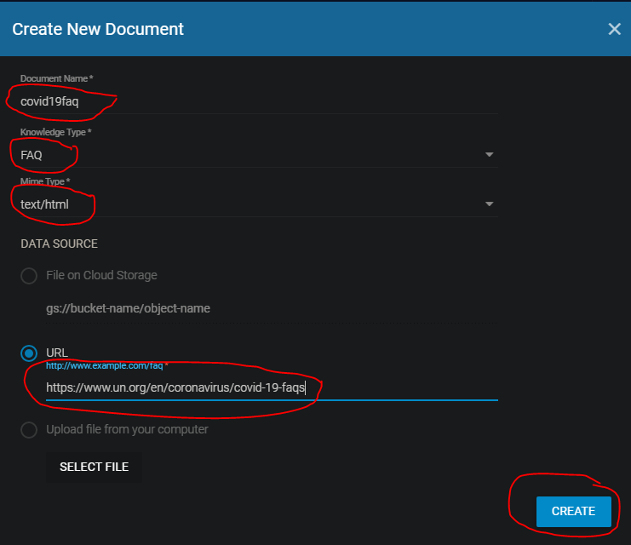

**Sample chat response for FAQ:**

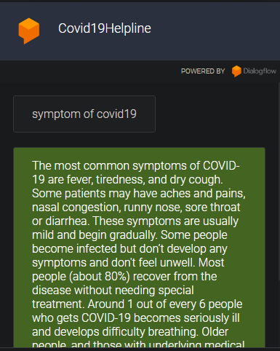

If user says no to your response like [ if User is interested in covid19 details or No further queries ]

Then you can do end of conversation. Use context to pass information from one intent to another.

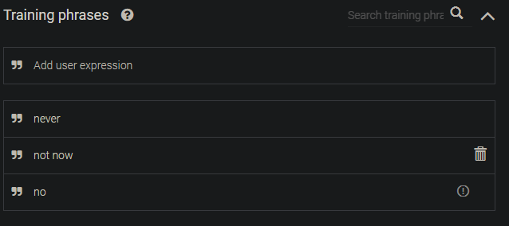

Once you are done with the conversation then enable below button.

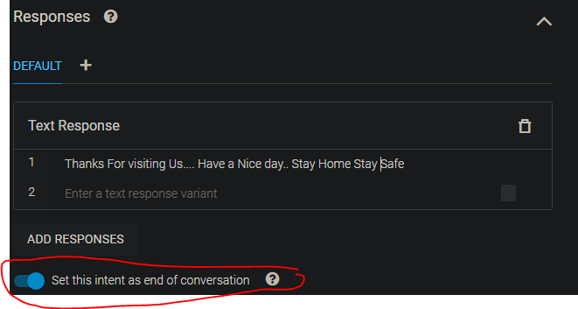

Django WebHook API

|  |  |
| --- | --- |
|  | This is backend Project structure. You need to create a virtual environment where you can install all required packages using pip install command. |

Here we need to create API for sending mail once User ask for information. This will be a POST request. We need to filter the our request from Chat Request to get Email-id and send details to the emailed.

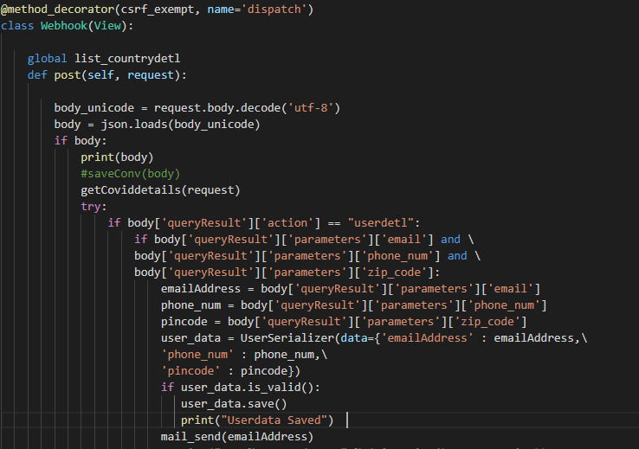

We are storing conversation in Mongo DB and user’s details in Sqlite3 DB.

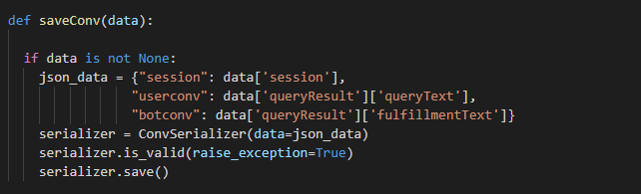



You can access User’s Data from Django Admin page.

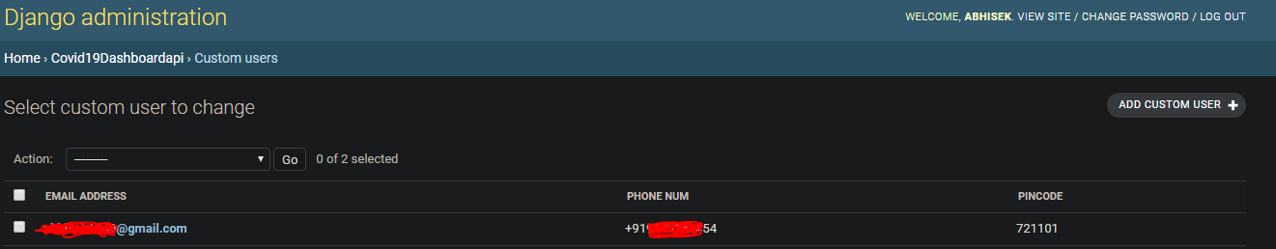

**Note: Important Configuration to be set in Django settings.py**

**Step1:** Allow your host which will access your REST-API. We can see ngrok URL has been allowed.



**Step2:** Add all required apps in INSTALLED_APPS.

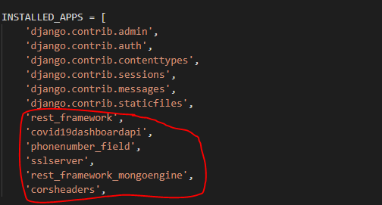

**Step3:** Add CORS middleware otherwise you will get an CORS error.

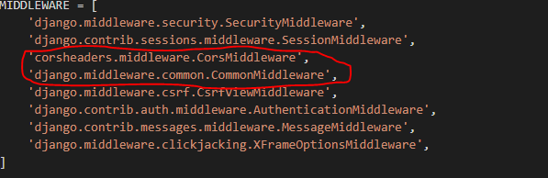

**Step4:** add your Mongo DB details. Please check the host configuration and put your username and password. You should encrypt your password. This is just used as a sample.

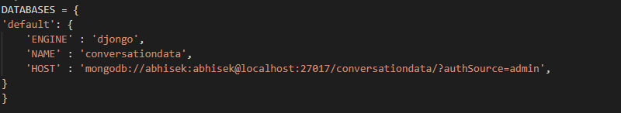

**Step 5:** Add email configuration. Password should be Encrypted and while committing your code in GIT make sure to use .gitignore to exclude storing settings file.

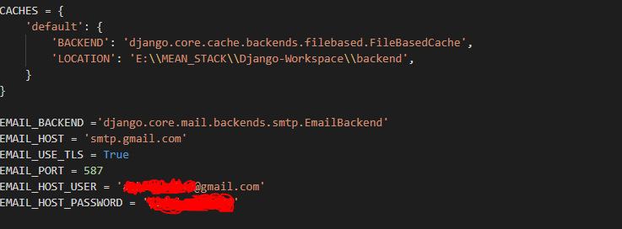

**Covid19 API Data:** we can use public rapidapi for getting worldwise covid19 details.

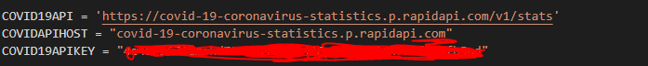

You can cache your data so that you can call this API less time otherwise it will be a load for their server also these data doesn’t change frequently. So it’s good to cache your data.

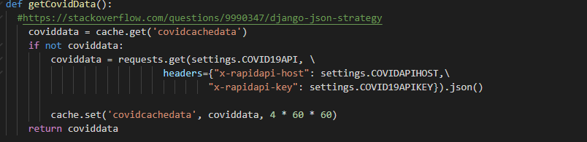

ANGULAR-Chat Window

|  |  |
| --- | --- |
|  | Project Structure for Angular. Inside your main app you can create an component called chatbot which will be used for message communication via APIAiClient.  All Api settings like google chat key will be stored in environment.ts file.    **Reference: [Angular ChatBot with Dialogflow (API.ai)]**  <https://www.youtube.com/watch?v=CKhV7-NF2OI>  watch above video to understand it better. Full Code repository is also given below. |

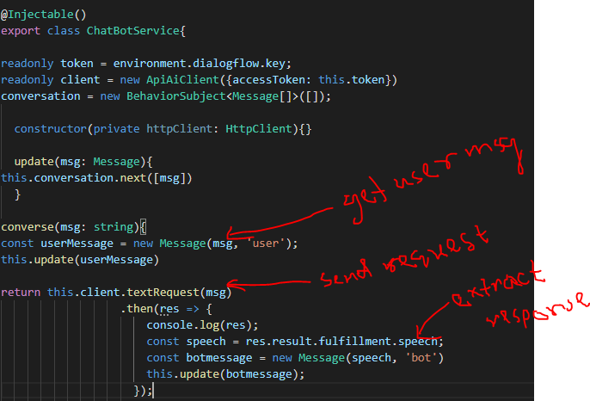

We have used observable to our Chat Service and concatenate updated messages and empty the form value.

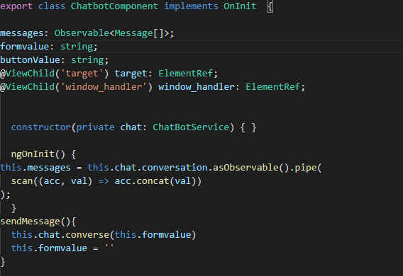

That’s it. You can do lot more of changes or adding new features.

Code repo: <https://github.com/abhi1540/DialogFlow-ChatBot-With-Angular>